built environment
Building Technology

Concept for renovation of facades with prefabricated wood elements
Karin Sandberg, Anna Pousette, Leif Östman
RISE Report : 2018:xx

Concept for renovation of facades with prefabricated wood elements
Karin Sandberg, Anna Pousette, Leif Östman

Abstract
Concept for renovation of facades with prefabricated wood elements
There is a major need of cost-effective renovation that leads to lower energy consumption and better environment. The aim with a Nordic built project was to develop a concept for industrially prefabricated insulated elements for renovation and upgrading of building envelopes. The project with participants from Sweden, Finland and Norway focused on increased prefabrication based on wood for a sustainable solution. This report also shows the results from a pilot case of the newly developed prefabricated building system. The renovated building is a one-storey office building located in Skellefteå in the north of Sweden. Energy performance, thermal bridges, risk of moisture problems, LCA, applicability of the renovation method and assembly time were evaluated during the planning and execution of the renovation. Results from this case show that the elements were very light and easy for one person to handle at the building site. There is a great potential to reduce assembly time with improved joints and element sizes adapted to the building as well as improved batch packaging from the factory. With 100 mm insulation, the renovation gives a certain energy saving. LCA calculations show that the reduction of climate impact due to reduced heating energy used during a service life of 50 years corresponds to the climate impact of the renovation measures. Environmental calculations show that with a thicker insulation, the reduction in climate impact during the use phase of the building increases more than the climate impact of the renovation. There is a great potential to reduce climate impact from the wall element by selecting materials produced close to the element factory with a greater share of renewable energy as well as shorter transports.

Key words: Façade renovation, Building envelope, Prefabricated wood element, Energy efficiency, Thermal bridge, Insulation, Climate impact, Retrofitting

RISE Research Institutes of Sweden AB
RISE Report : 2018:xx
ISBN:
Skellefteå

Content
Abstract 1
Content 2
Preface 3
1 Introduction 4
2 Attitude to façade refurbishing 5
3 Pre-fabricated facade systems 8
4 Concept of wood-based modular pre-fabricated facade system 8
4.1 Modular wall element system 9
5 Technical aspects of the system 10
5.1 Size of façade elements 10
5.2 Wall thickness and insulation 11
5.2.1 Thermal bridges 11
5.3 Moisture risks 12
5.4 Installation 13
5.4.1 Connections 13
5.4.2 Production, logistics and installation 13
6 Energy analyses and comparisons with other measures 14
6.1 Example of two-storey building 14
6.1.1 Energy savings with façade refurbishment systems 15
6.1.2 Energy savings of other types of refurbishment options 15
6.1.3 Energy savings of façade refurbishment systems including other refurbishment options 16
7 Cost-efficiency of refurbishment 17
7.1 Business model 17
7.2 New element system 18
7.3 LCA of renovation 19
8 Case Hedensbyn 29
8.1 Energy savings and thermal bridges 31
8.2 Moisture simulations and measurements 32
8.3 Buildability 33
8.4 LCA 34
9 Conclusion 35
References 36

Preface
This report was written within the project, Nordic Built Concept for renovation and upgrading of residential buildings, and is supported by Nordic Built, Swedish Energy Agency, The Swedish Research Council Formas and industry partners from Sweden, Norway and Finland. The work with “Case Hedensbyn“, was also presented in Nordic Renovation Center, a Nordic project with participants from Sweden, Norway and Finland to exchange best praxis and support regional participants with information and education about renovation, see www.nordicrenovationcenter.eu and https://solved.fi/. The project is financed by an EU Interreg program.
This is a summary report mainly based on four papers and two master thesis works [1, 2, 3, 4, 5, 6].
Participants in the writing were Karin Sandberg RISE Research Institutes of Sweden, Anna Pousette RISE, Anders Gustafsson RISE , Svein Ruud RISE, Joakim Norén RISE, Anders Bystedt RISE, Leif Östman Novia University of Applied Sciences Finland, Allan Andersson Novia University of Applied Sciences Finland, Mauritz Knuts, VASEK Finland, Mohsen Soleimani-Mohseni Umeå University Sweden, Thomas Orskaug Norwegian Institute of Wood Technology Norway, Joel Johansson Sweco PM Finland, Kim Westerlund, EduPower Oy Ab Finland, Henning Thorsen Termowood AS, Norway.

Introduction
This is a report from a Nordic Built project that investigated façade refurbishing from sustainable (social, environmental and economic) values and technical aspects. The focus was on residential buildings in Nordic countries, primarily in Sweden, Norway and Finland. Although the three Nordic countries have similar climate conditions and building traditions there are some differences that have to be considered before renovation. The vision was an industrially pre-fabricated wood-based system for renovation and sustainable upgrading of residential buildings in a cost-effective and high-quality retrofitting system.
There is a need for cost-effective renovation of buildings in Europe because of the increasing age of the building stock and lagging refurbishment. There is also a need for energy-efficient improvements because of European directives intended to lower the energy consumption due to environmental concerns. Improved energy performance is required for new buildings, but it is also necessary to improve existing buildings to achieve energy efficiency in accordance with EU directives [13]. Many buildings built in the sixties and the seventies, before the energy crises, provide great potential for substantial improvements in energy performance.
According to a study in Finland there is an annual need for refurbishment of 3.5 billion €, where the major increase is coming from the multi-story buildings. The estimated cost of neglected refurbishment in Finland is 15 billion € [7]. In Sweden an estimated need of renovation of 650,000 apartments, a cost of at least 30 billion € excluding energy saving measures [8].
The facades of these buildings are often in a need of a renovation. Typical reasons for renovation of façades are the needs of improved energy performance and airtightness but also the need for a ”face-lift” due to deterioration of the façade. Depending on the cause and extent of deterioration and the type of building, different solutions can be chosen. Most buildings must be refurbished at low costs and with limited disturbance to the users/tenants. Some typical buildings in Sweden and in Finland were used for theoretical studies to examine and compare renovation cases [1] (see Figures 1 and 2).
 | 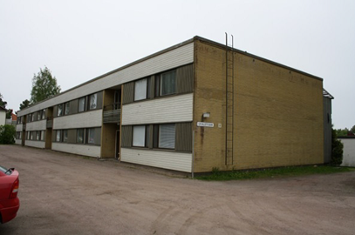
Figure 1. Skiftesgatan, Skellefteå, Sweden. | Figure 2. Grindstugan, Vörå, Finland

Refurbishment and especially the need for improved energy efficiency tend to push the limits of the economy of both housing companies and tenants and in less attractive areas even making a refurbishment impossible. A façade renovation affects the performance of external walls in terms of energy performance and lifecycle cost but also in terms of building performance, physical behaviour, durability and aesthetic appearance. Many joint European renovation research projects have been trying to find an optimal solution for renovation. Technical requirements and methods for renovation of facades have been studied and developed. There have been several attempts to develop renovation systems but so far none of them, based on their limited market share, seem to have provided an acceptable solution. Some projects have developed a facade renovation method based on prefabricated wood elements to improve energy efficiency [14, 15, 16].
There is also an intention to transform the building sector from its tradition of on-site building to an innovative, high-tech and energy-efficient industrial sector. Prefabricated wood elements can be made in advance in dry conditions indoors according to the assembly-line method. The wood elements built as complete as possible with insulation, sheathing on the inside and finished façade on the outside reduce assembly time on site. The wood based prefab industries for new buildings are well established but are mostly SMEs and don’t have the resources to develop new products and larger business concepts. This is generic for the Nordic countries and in most of Europe. Some of the reasons for this issue are found in the absence of business concepts, and in the lack of an overview of customs and regulations and requirements. It is also due to the fact that the chain of actors for renovation on the Nordic and European markets is unclear and based on historical traditions for refurbishment projects.
Today, renovation, upgrading and extension (added floors) are often conducted in the form of on-site construction. Existing façade renovation methods are often inefficient, and the risks are high for the contractors, making it difficult for the clients to find tenderers. The business situation is too unclear to open this market, due to lack of lean methods for refurbishment projects. The challenge in this project was to combine technical knowledge, business and entrepreneurship into cost-efficient and sustainable building envelope solutions and construction processes.

Attitude to façade refurbishing
Attitude to façade refurbishing in residential buildings and comparison of technical requirements in Nordic countries were investigated in the beginning of the project. The aim with the survey was to sort out the most important issues among persons and professionals involved. The web-based questionnaire was sent to a small number of professionals in the three Nordic countries, Sweden, Finland and Norway and was also complemented with some interviews.
The survey results are limited to a few central questions, namely the expectations of tenants and professionals regarding costs and outcome, leaving most of the detailed technical and environmental issues aside. Figure 3 shows the answers.

Figure 3. Average value of the answers from the 17 respondents, ten from Sweden (one woman), six from Finland and one from Norway. Scale 1-5 where 5 as very important.

The survey indicates the importance of cost efficiency, whereas the importance of using wood as a material scores rather low in the evaluation. Reducing the environmental impact reaches 3.8 and improving the attractiveness of the urban environment has an average of 4.3. Life-cycle-costs and economy, on the other hand, reaches an average of about 4.5. Long term and short-term economy are the most important issues. The attitude towards refurbishment of facades can be concluded in one sentence. The projects should produce a tidy and safe environment without stressing the economy to its limits.
Energy efficiency also scored rather high, with the value of 4.2.
Among the free text comments are expectations that the refurbishment of facades should improve the energy performance and thus reduce the cost of living. One of the comments also point out that there should be a gain in capital value - if the costs are high - but this is of course mainly an interest of investors and normally not of those renting apartments.
The refreshing approach stands out among the answers about these building types and the environment. It seems that there is a common understanding that these buildings can be renovated, and that the refurbishment of the facades is one of the issues related to the attractiveness (or the current lack of attractiveness). It is, however, clear that it this is not only about the facades but also about energy efficiency and the whole urban environment, including a comment regarding improved lightning outdoor to make it a safer environment. Many comments stress the need for tidiness and improved living conditions outside and also in the apartments.
From a technical point of view, the main aspects from a customer perspective are that:
- the solution is well thought through and has a positive impact on both the architecture and the inside living conditions
- thought is given to the unique construction of the house, so the life span is not shortened
- the system has well thought-out solutions for easy retrofitting of, for example, awnings
- the system improves the insulation to decrease energy usage and sound transmission
- the system has a short construction time and has long-lasting materials
- the solution has a low cost and a long time between re-investments
It is now more than 50 years since all the Nordic countries started large-size mass production of housing, mostly based on the erection of new neighbourhoods outside city centres, on new land. In the Nordic political tradition these are partly social housing projects, partly they might be based on private investments by the tenants. There are differences between the countries regarding the organization of housing developments. There is a tradition of promoting a social mix but there is also a tendency that low income groups live in these areas as the rents are low and the apartments can be bought at lower cost than in most other urban areas.
Many of these projects are now facing a demanding situation due to the ageing of the structures and the diminishing attractiveness of these houses and suburbs. They still provide cheap living conditions but due to the lack of maintenance and renovation there is a danger that it is not any longer feasible to invest into their rehabilitation, which of course will lead to further degeneration of the attractiveness and the apartments, as of the area as such and a loss of invested capital to the owners.
These apartments are modern regarding size and organization, but they don’t meet technical standards of today regarding energy efficiency, accessibility and ventilation. It is often estimated that the number of houses needing a renovation is continuously increasing due to the neglected refurbishment.
There are obvious differences in structure and construction materials even though these housing blocks are seen as dull and all being very similar, (see Figures 1, 2, 4 and 5)

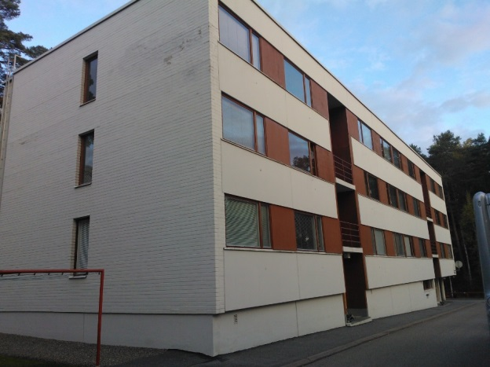 | 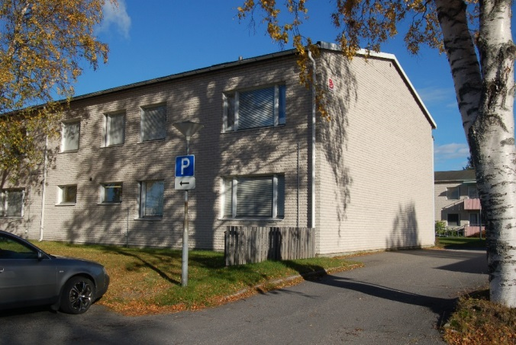
Figure 4. Housing block from seventies in Finland, Korsholm. | Figure 5. Housing block in Sweden, Umeå

Prefab construction methods have been very common in the Nordic countries since the sixties, especially in Finland and Sweden, but not all houses are prefab projects. It is quite common to have a concrete structure but the facades are of different types, both different types of sandwich elements and infill walls based on various materials The comment from a Finnish researcher (outside this survey) was that any façade refurbishment project competes with the low budget method of plaster on insulation, which is the most common method for renovating these buildings, but also partly seen as a risk structure regarding moisture.

Pre-fabricated facade systems
In the project two residential buildings were used for theoretical studies to compare renovation, Skiftesgatan, Skellefteå, Sweden and Grindstugan, Vörå, Finland (see Figures 1 and 2). The actual renovation of an office building was made at Hedenshyn, Skellefteå, see Chapter 8.
In general, the building processes are similar in the Nordic countries, but there are differences and variations between each country. There are differences regarding typical roof connections, fire regulations and energy efficiency in Finland, Sweden and Norway.
We also investigated two possible ways of producing wall elements. The elements are formed as far as possible with complete insulation, sheathing on the inside and finished façade on the outside in order to reduce the assembly time. One possible solution was to use traditionally large prefabricated wood elements made in advance in the factory according to the assembly-line method. The construction of the wooden elements is often the same as traditionally constructed walls. The other solution was the newly developed small elements that will be described further on and that are used in the case study.

Concept of wood-based modular pre-fabricated facade system
In this project, a new system of small, modular prefabricated wood elements has been developed for renovation of façades. The aim was to achieve more flexible solutions than those already existing. The new system is based on small scale prefabricated elements with a simple assembly process. The elements are smaller than conventional prefabricated wood elements, and the production will be more automated.
The alternative to prefabricated wood elements is on-site works, but prefabricated solutions will, of course, offer advantages. They are to be found in the dry production process combined with a simple and fast assembly on site. Similarly, there are advantages in the reduced number of thermal bridges and in the potential for the use of recyclable materials.

Modular wall element system
The pre-fabricated elements consist of an inner and an outer cross-laminated wood panel interconnected with slender wooden rods and with insulation in between (see Figures 6 and 7). The elements for renovation are non-structural elements and can have 50-250 mm of insulation.
The system can carry different cladding materials. The elements require some degree of removal of the outer wall structure, at least to the extent of uncovering the air barrier. All these measures require some work on site.
The main advantage of the modular elements compared to larger prefabricated elements with wooden studs is the energy efficiency that depends on the reduced number of thermal bridges, where the modular elements have a lower share of thermal bridges (only the rods). With few thermal bridges the elements are less sensitive to moisture, which otherwise might be a problem when adding insulation.

Figure 6. Modular wall system patented,  Termowood As; EP1963593, NO 323561. | Figure 7. Element without insulation, showing the slender wooden connection rods between panels

Other advantages are found in the simpler installation process and the fact that the installation can be done with smaller screws more frequently distributed, which is better tolerated on a weaker structure. In a renovation project, it can be difficult to accurately locate the load-bearing structures behind the exterior wall, as detailed drawings are often missing, and the walls have not necessarily been built exactly according to the existing drawings. Both larger and smaller elements are easy to install on a planar structure, but smaller elements, of course, tolerate minor unevenness in structures.
Installation should be possible on different types of buildings. Many buildings from the 60's and 70's have exterior wall constructions with double concrete walls with intermediate insulation. Many buildings also have concrete frames with end walls of concrete and infill walls (wooden studs and insulation) on the long sides. The adjustability to different types of building structures, materials, tolerances, geometries and energy requirements makes the small modular elements very applicable and efficient.
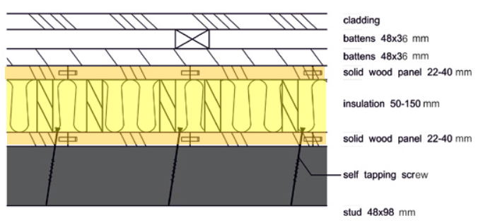
Figure 8. Example of a vertical cross-section of refurbishment of wall with wooden studs.

Technical aspects of the system

Size of façade elements
The modular pre-fabricated elements are produced in segments with a size range of width of 200 mm, a thickness of 94-230 mm, and a length of 2400-5000 mm. Thickness of the multi-layer cross-laminated solid wood panel is 22-40 mm and the connection rod length (and insulation thickness) is 50-150 mm. Wall elements can be combined in various sizes by assembling segments together horizontally or vertically using a tongue and groove connection, with a sealing strip in the joints to ensure airtightness.
The flexibility in terms of the mixture of element sizes and the independence of outer ventilated façade material enables the system to adjust to different building geometries, tolerances and energy requirements and to adapt to different façade expressions.
Maximum size of wall elements is governed by the transport limitations set by road authorities in each country and the dimensions of a trailer. The sizes of the elements have an impact on efficiency in production and assembly on site as well as the ability to adjust the elements to an existing building.
Measurement of existing structures, execution of the prefabricated elements and on-site production are important. The modular element system has an advantage compared with previously developed large-element systems, as it combines prefabrication advantages of elements and on-site work using smaller elements which makes it more easily adjustable to existing structures.

Wall thickness and insulation
Based on minimum thickness of 22 mm of the outer multi-layer cross-laminated solid wood panels and an insulation thickness of 50 mm, the minimum thickness of the modular wall element is 94 mm. Maximum thickness was set to 230 mm with 40-mm outer multilayer solid wood panels and 150 mm of insulation.
Due to the hollow structure of the elements, the panels can be prefabricated with blown-in insulation, insulation mats or both, depending on what is more efficient and economical for the individual project. Insulation can also be blown into the wall elements on site and mats used as complementary insulation. The thermal conductivity (λ -value) of the insulation materials vary from λ_{d}=33 mW/mK (stone wool mats) to λ_{d}=37 mW/mK (wood fiber blown in).
Two types of construction solutions have been designed for applying the modular system to concrete or brick walls or to wooden structural frame walls. For concrete and brick walls the system is built with a cavity layer of minimum 48 mm space between the existing wall structure and the element system. The cavity layer and the wooden panel in the refurbishment wall system can be used to dry out and stabilize the level of humidity in the existing wall surface. Vented fire barriers should be built in the cavities to prevent fire from spreading vertically.

Thermal bridges
As buildings become better insulated, the importance of reducing thermal bridges increases. The effects of thermal bridges on the overall thermal performance of a well-insulated building can be significant, up to 30% of the total losses. This can affect the air quality, "cold" walls feeling, and increased moisture risks inside the wall.
Heat transfer can occur through the building envelope in three ways: conduction, convection, and radiation. Conduction is the flow of heat through materials and is the primary concern in terms of thermal bridging, where areas have higher heat flow in comparison with adjacent areas. This occurs where there is a break in the insulation layer at for instance discontinuities in the wall structure, less insulation or where the insulation is penetrated by an element with a higher thermal conductivity.
U-value is a measure of the heat transmission capacity of a wall section. It is by definition the inverse of thermal resistances. Heat losses escaping from thermal bridges of a building envelope are determined by considering 1-D, 2-D and 3-D heat flows. The physics equations are usually expressed in terms of partial differential equations. They are difficult to solve with analytical methods, instead, an approximation of the equations can be solved using numerical methods such as finite element method (FEM), e.g. COMSOL® Multiphysics Software.
Limiting thermal bridges is the best way to build more energy efficient constructions. Three different methods exist to limit thermal bridging: internal insulation, external insulation and thermal bridge breakers. External insulation is one of the best ways to avoid heat losses, but usually there are still some discontinuities in this insulation.
Thermal bridges in existing buildings can be detected by thermography, see Figures 9 and 10.
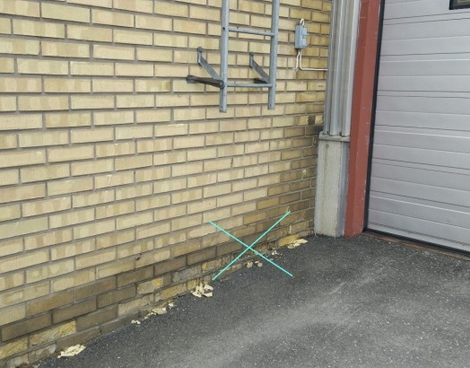 | 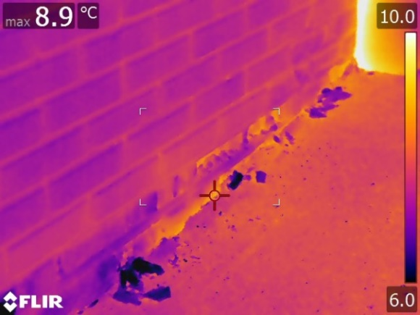
Figure 9. Photo of the south east wall from the outside. | Figure 10. Thermographic picture of south east wall

Moisture risks
Simulation of moisture in different wall constructions with the modular system was done with WUFI® program. Weather conditions of Umeå, Sweden, were used. Both symmetrical and asymmetrical constructions of the modular wall system, with 22-mm and 40-mm thick solid wood panels, were simulated with 50-mm and 150-mm insulation in between. The results from the simulations showed no sign of problems with condensation in the element.
In terms of thermal bridges, the modular system has, with its connection rods in wood (d=30 mm and a raster spacing of 160 mm x 500 mm), a thermal bridge area of approximately 212 cm²/m² wall, unlike a standard light frame wall with 48 x 98 mm studs c/c 600 mm spacing which has an area of 960 cm²/m² wall. The significantly lower thermal-bridge area in the modular wall system reduces the risk of condensation.
The airtightness and wind tightness of the refurbishment layer is ensured by using sealing strips in the joints between elements, and with adhesive tape at window connections and over the joints between elements and sills. An air leakage test done according to standard EN 13829 at a multi-family house in Norway built with a modular wall system gave a result of 0,67 m³/m³h which fulfills the Norwegian building regulation airtightness demands of ≤ 1,0 m³/m³h for low energy class 1.

Installation

Connections
For existing façades of brick or concrete, wooden battens are added to the load-carrying structure by using wall connectors or concrete anchor bolts and screws. The purpose of the battens is to equalize for imperfections in the existing surface and to make it easy to attach the modular element with self-tapping screws. On a wooden structural frame wall, the refurbishment modular system is fixed directly to the load carrying studs with self-tapping screws, given that the studs can carry the element and the outer cladding.
The modular element system is designed with the prerequisite that the load-carrying structure in the existing façade can carry the self-load of the exterior refurbishment construction. To prevent vertical displacement in the modular elements due to heavy cladding and long-term load effects, the tops of the elements can be connected to the ends of the roof trusses with metal purlin anchors. Metal brackets can also be mounted at the base of the wall to carry the vertical loads of the elements. The ability to attach brackets to an existing building structure depends on its state and can be challenging.

Production, logistics and installation
The modular system has been focused on both product development and production development with the aim of obtaining the optimum product within cost. The main objective has been to design a system that can generate a profitable industry in the Nordic countries for production of renovation elements.
The production plant should be highly automated and using a system that ensures efficiency and reduced costs. The logistics are going to need some buffering in the system to handle the variations in the site installations. A plant for production of modular units at full-scale has been shown to be able to produce 60 items per hour or 480 items per shift (250 m²) with three workers. In a separate set-up that has been developed, individual elements can be assembled into larger elements at a speed of two items per minute (1 m²).
After the prefabrication of elements, they are preferably loaded directly onto curtain trailers to ensure dry and safe transport to the building site or to a weather protected buffer area. In order to have a swift installation on site, the elements should be arranged in a set assembly order. Rain protection during transport and storage at the building site is important to prevent moisture from entering the modular wall system.
Installation on site should be conducted more or less continuously for speed and reduced moisture exposure. It also allows the tenants to remain living in the apartments during renovation. The elements can be assembled both horizontally and vertically. Cladding can be mounted during prefabrication of the elements or be completed on the building site. Prefabricating the elements with battens for the ventilated cladding will connect the segments and stiffen large-size elements.
To make the assembly of the prefabricated elements more efficient, metal connectors can be installed on the back side of the elements and on the existing façade. Alternatively, two and two elements are produced and fastened to battens, which are assembled on existing façade using self-tapping screws. A major aspect to streamline the installation is a requirement to stay within tolerances of less than ±20 mm.

Energy analyses and comparisons with other measures
The energy analyses concentrated on thermal bridges and U-values, relating it to the total energy performance and compared to the current situation and comparable refurbishment methods with wooden structures. The amount of insulation can be increased but this analysis is limited to 50-150 mm of added insulation, as a complement to an estimate of 100 mm in poorly insulated buildings built 1965-1975.
The aim is improving the U-value of the exterior walls. It seems that both the regulations and the researchers [1] have come to similar conclusions regarding a feasible U-value for façade refurbishment, i.e. a U-value around 0.17-0.18 W/m2K.

Example of two-storey building
A typical low rise multi-family building from the period 1965 to 1975 was chosen as a reference building. It is located in Vörå, Finland, but calculations were made with climate data for Umeå in the north of Sweden with similar climate. It has a concrete frame with infill walls (wooden studs and insulation) on the long sides. The windowless short sides consist of concrete, insulation and bricks.
Table 1. Reference 2-storey building
Total surface area of heated indoor air (A_{om}) | 2092 m²
Total floor area for temperature-controlled spaces (A_{temp}) | 1196 m²
Total floor area of the 18 apartments | 1080 m²
Total floor area of stairways and partition walls. | 116 m²
The air tightness (q_{n50}) assumed | 0.8 l/s and m² A_{om} at 50 Pa pressure difference
Climatic data for Umeå, Sweden, mean outdoor temperature | +4°C

Calculations were made with program IDA-ICE and TMF Energi. With assumed heat transmission capacity (U-values) and linear heat loss coefficient of thermal bridges (Ψ-values) this gives an average thermal transmittance (U_{m}) of 0.630 W/m²K and a specific energy use (E_{spec}) of 231.1 kWh/m²a. Operational electricity is 8.8 kWh/m²a and district heating is 222.3 kWh/m²a. The latter consists of 7.3 kWh/m²a hot water circulation losses, 25.0 kWh/m²a use of hot tap water and 190.0 kWh/m²a space heating. As the building envelope of the reference case is rather poorly insulated the thermal bridges stands for less than 8% of the total U_{m}-value.

Energy savings with façade refurbishment systems
The influence on the specific energy use for three different façade refurbishment systems was calculated:
• 50 mm thermal-bridge-breaking on-site mounted additional isolation (total U-value 0.26 W/m²K)
• 100+50 mm on-site mounted additional insulation (total U-value 0.18 W/m²K)
• A modular pre-fabricated façade renovation system (total U-value 0.18 W/m²K)
For all three renovation systems two different linear thermal bridge values have been used around the windows, corresponding to a good and a less good assembly of the window frames. For the 50 mm system the linear thermal bridge values were estimated from values in literature. For the 100+50 mm on-site assembly system and the modular pre-fabricated façade refurbishment system detailed calculations were made in Comsol Multiphysics.
Table 2. Linear thermal bridges around the windows used in the calculations (W/mK).
Refurbishment system | Good | Less good
50 mm thermal-bridge-breaking system | 0.050 | 0.080
100+50 mm on-site mounted system | 0.041 | 0.076
Modular pre-fabricated system | 0.036 | 0.066

Table 3. Thermal transmittance and specific energy use for “good” and “less good” thermal bridges
Refurbishment system | Average thermal transmittance (Um) (W/m²K) |  | Specific energy use (Espec)  (kWh/m²a) |  | Energy savings (ΔEspec)  (kWh/m²a)
Original building | 0.630 |  | 231.1
 | “good” | “less good” | “good” | “less good” | “good” | “less good”
50 mm thermal-bridge-breaking system | 0.575 | 0.581 | 215.9 | 217.6 | 15.2 | 13.5
100+50 mm on-site mounted system | 0.543 | 0.550 | 207.4 | 209.3 | 23.7 | 21.8
Modular pre-fabricated system | 0.542 | 0.548 | 207.1 | 208.8 | 24.0 | 22.3

The energy savings due to the façade renovation system is decreased by 25% if the reference building is moved from Umeå, with a mean outdoor temperature of +4°C, to the west coast of Sweden, with a mean outdoor temperature of +8°C.

Energy savings of other types of refurbishment options
To compare the energy savings of the façade refurbishment systems with other energy saving measures the influence of some of the most common measures was also calculated, each as a single measure. The results are shown in Table 4.
Table 4. Influence of other types of energy saving measures.
Measure |  | U_{m} (W/m²K) | E_{spec} (kWh/m²a) | ΔEspec (kWh/m²a)
Windows | U-value 2.8 to 1.2 W/m²K | 0.491 | 193.1 | 38.0
Doors | U-value 2.0 to 1.2 W/m²K | 0.617 | 227.4 | 3.7
Roof/attic floor | U-value 0.27 to 0.13 W/m²K | 0.588 | 219.5 | 11.6
Air tightness | Q_{n50}-value 0.8 to 0.3 l/s m² | 0.630 | 226.9 | 4.2
Ventilation heat recovery | From 0 to 80/75 % recovery | 0.630 | 187.2 | 43.9

Energy savings of façade refurbishment systems including other refurbishment options
The façade refurbishment systems should be combined with all the other energy saving measures to reach a very low energy use, see Table 5.
Table 5. Thermal transmittance and specific energy use for façade refurbishment with “good” thermal bridges, and together with all other measures presented in Table xx
Refurbishment system | Average thermal transmittance (U_{m}) (W/m²K) | Specific energy use (E_{spec})  (kWh/m²a) | Energy savings (ΔE_{spec})  (kWh/m²a)
Original building | 0.630 | 231.1
50 mm thermal-bridge-breaking system | 0.381 | 113.7 | 117.4
100+50 mm on-site mounted system | 0.352 | 105.9 | 125.2
Modular pre-fabricated system | 0.351 | 105.6 | 125.5

The energy savings due to the façade renovation systems are decreased when combined with all the other energy saving measures. For the modular prefabricated system this means an energy saving of 22 kWh/m²a instead of 24 kWh/m²a. The reason is that the heating season is decreased due to the other energy saving measures.
The most effective energy savings measures for this typical multifamily building from the period 1965-1975 is installation of ventilation heat recovery and new energy efficient windows. But the third most effective measure is the façade refurbishment. Air tightening and changing to energy efficient doors is the least effective single measures. However, if combined with balanced ventilation and heat recovery the air tightening will be twice as effective. Better air tightness of the building envelope may also be needed to avoid condensation and moisture in the outer parts of the wall. The length of thermal bridges around the windows is the longest of all the thermal bridges in this type of building and they need attention to minimize significant and unnecessary heat losses.

Cost-efficiency of refurbishment
Buildings built in the sixties and the seventies, before the energy crises, provide great potentials for improvements with the energy renovation. One major issue is that these buildings must be refurbished at low cost, as the rents cannot increase too much if the present tenants should be able to stay. The refurbishment process should also be conducted with limited disturbance of the tenants. Facade renovation methods can be improved to decrease inefficiency and risk for contractors.
The business situation is unclear, due to unclear means for refurbishment. The construction process is project-based with a production system, a site and a temporary organization. Construction projects include multiple actors, and therefore the communication in the process is extensive and complex. Case analysis with a qualitative approach was carried out and evaluated with interviews, documentation and observation. The aim was to understand the business model aspects in the refurbishment process.

Business model
A new business model should include standardized products, logistics and project management. There is a need for clear distribution of risks for the business partners and a clarification of potential co-benefits. Basically, the proposed contract model has a contractor taking the full responsibility towards the client, including the detailed refurbishment design and project management. The business model is based on cooperation between main contractor, architect and element production. The logistics and installation chain, combined with standardized methods for measurements, installation and completion works is essential.
The project has focused on product development at the same time as production development. In order to establish a competitive industry in the Nordic countries compared to low-cost countries, the production facilities must produce as much or more as by approximately 70% reduction of workforce. There has been challenges in developing effective building elements of wood which are competitive in price. The new system solves this challenge through;
• Focus on production and an innovative product development; a prefabricated system in an automated production line that ensures efficiency and reduced costs.
• Focus on a product of wood that can be produced at a volume market, with an investment cost which is competitive in the market.
An existing test plant can produce 20 items per hour or 140 items a day (60-70 m2), performed by 2 -3 workers. A full-scale facility could produce 60 items per hour or 480 items per day with 3 workers.

New element system
Concepts for façade renovations consisting of an efficient and functional chain of service providers working together producing service to the customer still have to reach the market. The concept of a pre-fabricated façade renovation system could be part of the solution with a chain of consultants, contractors and producers behind a one-point service provider.
The system element is an environmentally appropriate product for insulation and replacement of the wall. It replaces conventional on-site step-by-step installation methods. The possibilities lie in reduced costs between 20-30% related to the on-site construction, thinner walls than conventional solutions, flexibility that the elements can be supplied by different thicknesses / insulation value, flexible according to width and height by several elements assembled, reduced waste and surplus materials on building site. The uniqueness of the new element system is a fast construction time depending on easy installation. The results are low construction costs, increased thermal insulation in buildings, reduced transportation costs, reduced time spent on site, and less mistakes. The product is flexible and can be delivered both as small and large items. Table 6 shows a study of time at construction site. These calculations are based on a two-story building with a 596 m² facade. The following assumptions have been made regarding the renovation work: existing exterior walls are demolished, at site insulation alternatives only the outer layers are removed, new wall materials or elements including necessary work on the inside such as plasterboard etc. as well as surface finishing of the façade, new windows and balcony doors, new balconies.
Table 6. Time consumption at site
Alternatives | Refurbishment solution | h/m2
Alt. 1 | The facades are insulated at site with traditional framework (50 mm) | 1.8
Alt. 2 | The facades are insulated at site with the system element (50 mm) | 1.0
Alt. 3 | The facades are refurbished with larger system elements and with non-supporting structures (150 mm) | 1.1
Alt. 4 | The facades are refurbished with the system element and with supporting structures (150 mm) | 1.3
Alt. 5 | The facades are refurbished with the system element and with non-supporting structures (150 mm) | 1.3
Alt. 6 | The facades are insulated at site with traditional framework (150 mm) | 2.5

As seen in Table 6 the time at site is reduced compared to on-site refurbishment, the figures for the system resembles other systems with prefabricated elements. There is a readiness in the system to reduce waiting time and allow for detailed adjustments to the existing building. It is of course also important to consider what the impact will be on the surrounding area and on the architecture. A remaking of the facades will offer an improvement of the attractiveness of the buildings, which will have a positive impact on both tenants’ interest to rent an apartment in the area and also on the value if the apartments. There is, however, an obvious need to improve the outdoor areas as well. A redesign of the exterior architecture provides an opportunity for refreshing the image of the area and the buildings.

LCA of renovation
A refurbishment of an old building while improving its energy efficiency is often an environmentally sound measure. The alternative to a renovation is to replace the old building with a completely new one.
An old structure that is reused can be considered environmentally free and does not cause any environmental impact. However, the adaptation of the existing building prior to the conversion involves an environmental impact from, for example, removal of old facade or other materials in the wall.
Using LCA calculations, it is possible to evaluate how different refurbishment systems and choices of materials affect the environmental impact in the different phases of the refurbished building lifecycle, usually 50 years. That is, with the new function of the building. The environmental impacts refer to all stages of the life cycle, i.e. manufacturing and assembly, use and end of life and can be calculated according to EN 15804.
Figure 11 shows the climate impact of 1 m² of Termowood’s wood elements with 22 mm solid wood panels and two other systems/products for onsite renovation of timber buildings. These are Climate Board ZERO from Paroc and Façade board 30 from Isover. The calculation shows the impact of the production phase of the systems and transport to a building site in Skellefteå in the north of Sweden. The calculations of the different systems are based on EPD data and general data. In this case the TermoElement results in a higher contribution to climate impact than the other systems. However, this is mainly because Termowood’s element contains more material and these are produced in central Europe with electricity containing a great proportion of fossil fuels and with long transports to Norway, see Figure 12.
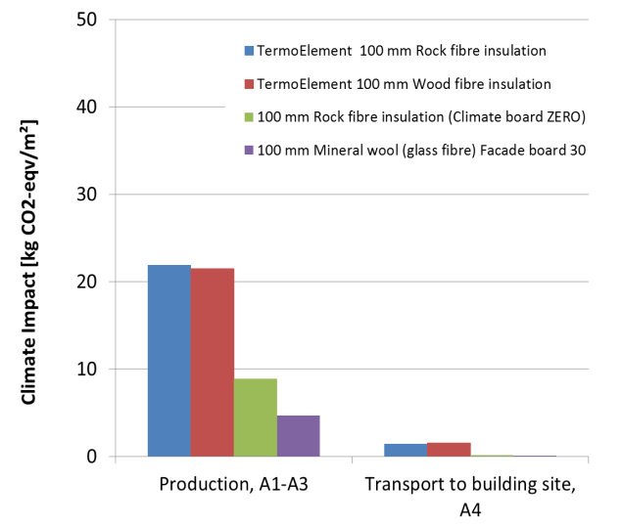 | 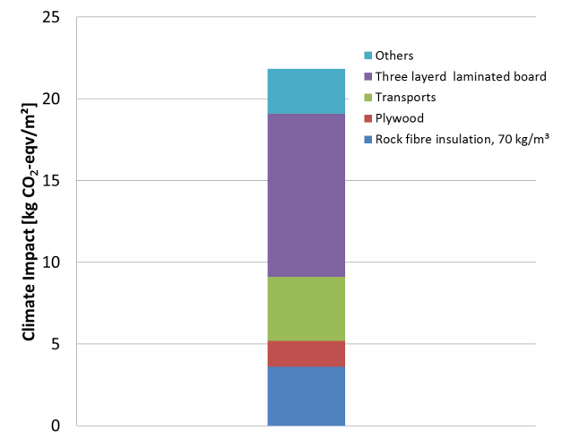
Figure 11. Climate impact of 1 m² for the production (A1-A3) of different renovation systems and transport to building site (A4) in Skellefteå. | Figure 12. Climate impact for production (A1-A3) of 1 m² of Termowood element with 100 mm rock fibre insulation

Case Hedensbyn
“Case Hedensbyn” is an office building built in 1976 that needed refurbishment. It was used as a first case for testing the new refurbishment system. The building is located in Skellefteå, in the north east of Sweden. It is a one-storey building, 10.18 m x 23.7 m, that is connected to a larger machine hall (see Figure 1213). The tenant is a company with focus on mobile communication.
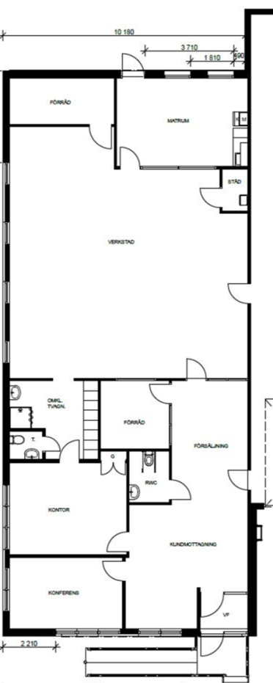
Figure 13. Plan drawing of the office building.
It was built with a timber frame and had a yellow brick facade, see Figure. 14. The bricks had started to fall off and the façade had been complemented with red profiled steel sheet on the north side of the building, see Figure. 15. The original wall was built of 13 mm gypsum board, 0.15 mm polyethylene foil, 140 mm of glass wool insulation and 145 mm wooden wall studs, 12 mm bitumen impregnated fibreboard, 10 mm ventilated air gap, 65 mm facade bricks or 0.7 mm profiled aluminium sheets above and between the windows.

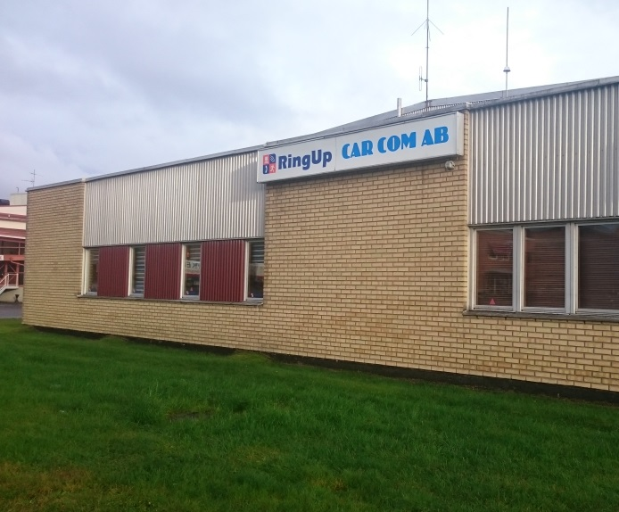 | 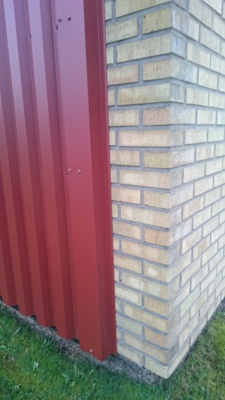
Figure. 14. Photo of the building before renovation. | Figure. 15. Photo of the building before renovation, north wall with extra steel sheet.
The bricks were removed from the wall, see Figure 16. For use of elements on existing walls, the size, attachment and tolerances of the elements are important for the installation of the new elements directly to the existing wall, see Figure 17. This also requires no moisture damage or mould growth in the existing wall. In case Hedensbyn the thickness of the new wall elements had to be adapted to the existing roof-overhang and base structure and therefore the elements had only 100 mm additional insulation. The outer solid wood panels of the elements were 22 mm thick. Standard width of elements was 200 mm, but also 98 mm wide elements were used to adopt to windows. The element length was generally 2.05 m and elements were installed in two layers to get the full wall height. The elements were fixed to sills that were screwed to the existing building at bottom, middle and top of the wall. The new façade cladding was a red painted softwood façade.
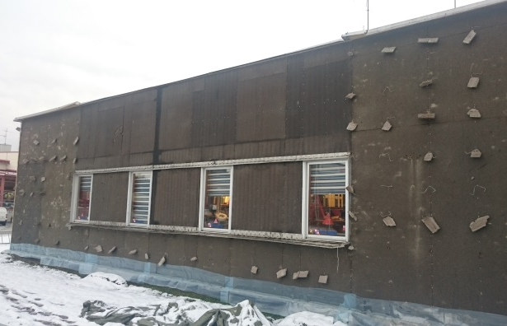 | 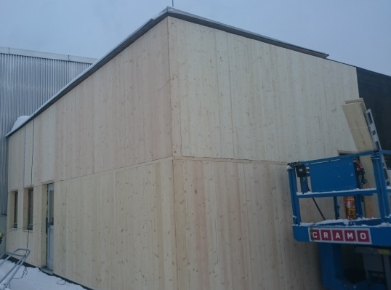
Figure 16. Building after removing the brick façade and aluminium sheets. | Figure 17. Building with new insulation elements.

Energy savings and thermal bridges
The software IDA ICE was used for calculation of energy savings. The energy saving was 9 kWh/m² per year when simulating the new façade element in IDA ICE. The existing building had a calculated annual energy consumption of 258 kWh/m², and the renovated building with 100 mm additional insulation got an annual energy consumption of 249 kWh/m².
In this case the thermal bridges caused by the timber frame were studied to assess how much energy could be saved by reducing these thermal bridges. 1D, 2D and 3D-simulations with software COMSOL were used. Simulation results of thermal bridges showed that the temperature difference between points on the inside of the wall at the position of studs and position between studs (no thermal bridge) was reduced with added insulation. Average on the year after refurbishment was 0.41 °C. From this the energy losses were also calculated. The calculated energy savings on average was 3.5 kWh/m² wall surface in a year because of reduced thermal bridges at the studs.
Thermographic pictures taken before the renovation are shown in Figures 18 and 19. A FLIR T620 camera was used to investigate thermal bridges in the existing building envelope. The thermography was made in May 2017 and carried out at night for the outdoor temperature to be as low as possible.

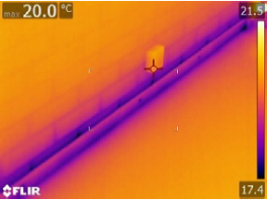 | 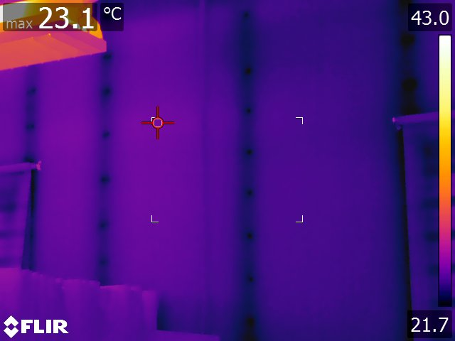
Figure 18. Example of thermographic picture of the skirting along the floor. | Figure 19. Thermographic picture on the north east side of the building

Moisture simulations and measurements
DOF-THERM software calculations showed that for January with outdoor temperature -12°C and indoor +20°C there is risk of condensation on the outer wooden plate in the element and therefore a vapor proof barrier in the wall is important. WUFI® simulations did not indicate any risk of condensation on the outer panel, but some simulations of the actual wall and climate showed that the outer wood panel in the northern wall will reach RH just over 80% during the winter months and the insulation closest to the outer panel will get RH 80-90%. Seven sensors were installed in the wall to follow up moisture content (MC), relative humidity (RH) and temperature (T) in positions that are believed to have the greatest risk of moisture damages, see Figure 2. HygroTrac sensors S-900-1 from General Electric are wireless and easy to use, see Figures 20, 21 and 22. Measurements are planned to continue during several years. Some initial measurement results are shown in Figure 23.
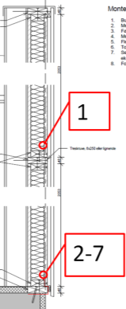
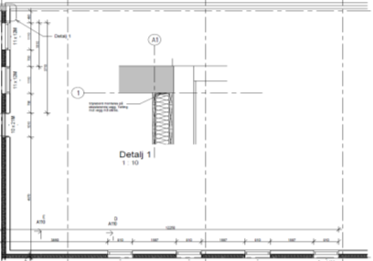
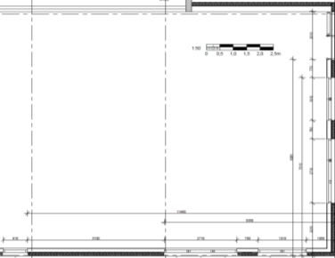
5
7
6
4
2
1,3

Figure 20. Position of RH- and temperature sensors. To the right, wall cross section with position of RH and temperature sensors.
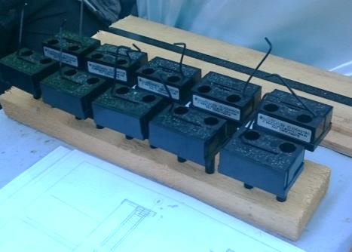 | 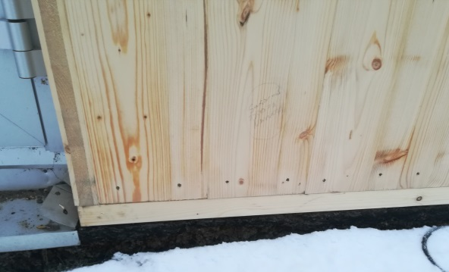
Figure 21. Sensors to be installed in the wall. | Figure 22. Location of sensor 3 marked in red ring (installed on the inside of the outer wood panel)

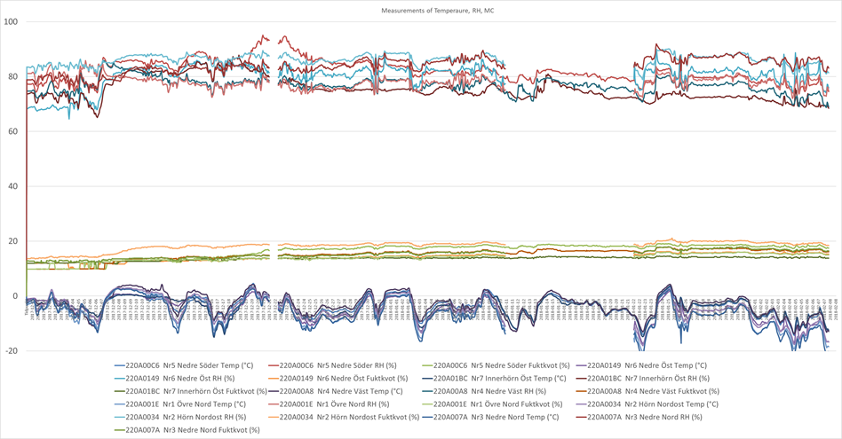

Figure 23. Measurement of temperature and moisture in wall elements, 2017-12-01 – 2018-02-08. RH 65% - 95%, MC 15% - 20%, Temp -20°C - +5°C.
The measurements show ……..

Buildability
The elements were short and had low weight and were easy to handle and lift at the building site. There was some trouble with assembling elements which had distorted tongue and groove connections after packages being stored on site and elements handled in wet snowy weather. Therefore, repacking and storage of elements after finished working days are also important to reduce moisture impact. The grooves were deformed making them too narrow and an extra effort was needed. This was labor-intensive banging with a hammer to bring together both the front and rear joints along the element edges. The rear was most difficult as elements bent outwardly from existing wall when simultaneously pulled together with straps.
In order to make prefabricated elements, it is important to have precise information about the existing building so that all adjustments to windows, doors and other details can be ready in advance. Then the assembly at the construction site will be quick. In this case some adjustments had to be made on site.
Average assembly time of the elements at pilot project “Case Hedensbyn” was about 0.5 h/m² façade when everything went well, and the assembly time was about 2-3 times longer where there were problems with the tongue and groove connections of the elements.
…………
……………..

Photo

LCA
The LCA calculation was made with EPD-data [11] and general data. Stages were according to EN 15804 [12] and included removals of waste material from demolition (brick façade, sheets etc.), new materials and transports.
The LCA calculations show the climate impact of the renovation compared with the reduced climate impact of the energy savings according to IDA ICE simulations in 3.1. The renovation gives a certain energy saving for this case building, but as the roof is not renovated, the overall profit will not be that big. But the renovated building has of course an improved performance and a better indoor comfort when the thermal bridges decrease and the air tightness increase.
Energy for the heating of the building comes from a district heating plant (biofuel). The results show that the reduced climate impact of energy savings over the lifetime of 50 years for a wall element with 100 mm insulation corresponds to the climate impact for renovation and maintenance, see Figure 24. With 200 mm stone wool insulation, the reduction in climate impact of energy savings is about 40 percent greater than the climate impact for renovation and maintenance. The results are about the same for stone wool and cellulose fibre. This can be explained by the fact that some of the materials used in the wall-element are produced in central Europe with a larger proportion of fossil fuels as well as long transports. It appears that there is a great potential to reduce climate impact from the wall element by selecting materials produced close to the element factory with greater share of renewable energy as well as shorter transports.
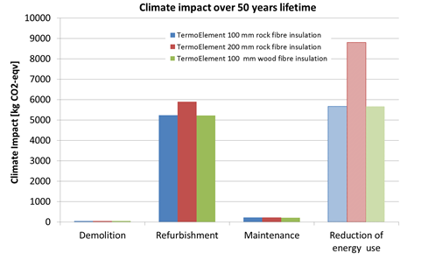
Figure 24. Climate impact over 50 years lifetime, compared to climate impact due to reduced energy use (patterned bar)

Conclusion
It is obvious that economic feasibility is central to this type of projects. Based on this survey and other previous studies it is clear that there is a limit for tenants’ interest to stay in these apartments and to be able to pay a rent that can support the maintenance and refurbishing. This includes the secondary assumption that constructors must find ways to make a profit out of these renovation projects, and if the profit is small the risk must be limited.
All parties stress this issue. It seems that further analysis will be needed since there are diverging interests and thus different relations to the costs. Depending on the market it seems obvious that in times with high demand for constructors’ services these objects will not be renovated as they offer lower potential for profit. Thus there is a need to find business models that offer more clarity of risks and reduced risks to all parties.
The positive outcome of refurbishment projects is clearly related to the cost-benefit question. Both professionals and tenants see the outcome in the form of an attractive living environment as important. These objects, as any market-oriented housing and areas, will depend on improving the attractiveness that will contribute to the market value and the potential to attract tenants that can afford to pay the necessary rents.
One interesting point is the relation to support from local authorities. Many of the respondents see the urban environment as important, which in the Nordic countries definitely is a responsibility of the authorities. As these areas currently include mostly low cost apartments, it seems obvious that the municipalities could continue to provide affordable housing by investing in the outdoor environment in these areas. There is also a study showing that facility managers see it as more important that we get tools for decision making rather than financial support [12].
In the case study the sustainability falls rather short compared to the initial expectations. It is necessary to optimize the product and its qualities referring to LCA. It might be that it is state of the art today to achieve a result where the refurbishment climate impact is compensated by the improved energy efficiency, but there seems to be potential for better results with an improved chain of suppliers and minimize the transport distances.
It seems likely that the method of element assembly offers a scalability that will provide opportunities to make the refurbishment process more efficient. It is, however, necessary to test it on a higher building and to find ways to streamline assembly methods avoiding pitfalls. The problems that occurred in the case Hedensbyn are easy to correct.
For a prefabricated renovation solution, it is important to have accurate information about the existing building both in terms of dimensions and materials. To get a quick assembly at the construction site, all adjustments to windows, doors and other details should be solved and included in the renovation system. This requires drawings of the original building and all subsequent adjustments or some measurement of the existing structure. Also, examination to ensure that there are no problems for renovating with the prefabricated system or if any additions to the existing building are needed.
The next step is to develop the business model into a concept where the entrepreneurial risks are reduced and each partner in the refurbishment process can understand what the refurbishment projects will provide and what it will cost.

References
- Sandberg K., Orskaug T., Andersson A., 2016. Prefabricated Wood Elements for Sustainable Renovation of Residential Building Façade, Energy Procedia 96 (2016) 756–767.
- Ruud S., Östman L., Orädd P., 2016. Energy savings for a wood based modular pre-fabricated façade refurbishment system compared to other measures, Energy Procedia 96 (2016) 768–778.
- Bystedt A, Knuts M., Johansson J., Westerlund K, Thorsen H., 2016 Fast and Simple – Cost efficient façade refurbishment, Energy Procedia 96 (2016) 779–787.
- Karin Sandberg, Anders Gustafsson, Anna Pousette, Joakim Norén and Mohsen Soleimani-Mohseni, Renovation of an office building with prefabricated wooden element - Case Hedensbyn, Cold Climate HVAC 2018, The 9th International Cold Climate Conference, Sustainable new and renovated buildings in cold climates, Kiruna, Sweden, 12-15 March 2018
- Wikner Malin, Holmstedt Zandra, Utvärdering av renoveringssystem för ytterväggar (Evaluation of refurbishment system for external walls) (in Swedish), B.Sc. Thesis - Energy Engineering, Dep. of Applied Physics and Electronics, Umeå University, Sweden.
- Orädd Fhilip, The effect on thermal bridges on buildings annual energy usage A comparative study of two refurbishment methods, Master Thesis 30 hp, Umeå University, Spring 2018.
- Hietala, M., Huovari, J., Kaleva, H., Lahtinen, M., Niemi, J., Ronikonmäki N-M. and Vainio, T. (2015). Asuinrakennusten korjaustarve. Kiinteistöliitto, Helsinki.
- Sveriges Byggindustrier 2013; Fakta om byggandet; http://www.bygg.org (in Swedish)
- Blom Peter, Termowood elementer, SINTEF Rapport no SBF2015F0287(in Norwegian) (2015-06-16).
- EPD TermoElement, 2016, www.epd-norge.no
- EN15804:2012+A1:2013 Sustainability of construction works - Environmental product declarations - Core rules for the product category of construction products, 2013
- Femenías, P., Thuvander, L., Mjörnell, K. and Lane, L. (2015). Koll på hållbar renovering. Bygg & teknik 2, 2015.
- Directive 2012727. European Parliament and the Council.
- Heikkinen, P. et al (2009). TES Energy Façade. Energiatehokkuuden parantaminen puurunkoisilla ja esivalmisteisilla julkisivuelementeillä. Helsinki: Aalto Univeristy.
- Hoppe, M and Hauser, G. Holzbau der Zukunft. TP 10 Energetische Sanierung von Bestandsbauten in Holz- und Massivbauart unter Einsatz von Holz und Holzwerkstoffen. Technische Universität München.
- Malacarne, G, Monizza P, G., Ratajczak, J., Krause, D. Benedetti, C. and Matt, D.Prefabricated Timber Façade for the Energy Refurbishment of the Italian Building Stock: The Ri.Fa.Re. Project. Bolzano: Free University of Bolzano-Bozen.

Through our international collaboration programmes with academia, industry, and the public sector, we ensure the competitiveness of the Swedish business community on an international level and contribute to a sustainable society. Our 2,200 employees support and promote all manner of innovative processes, and our roughly 100 testbeds and demonstration facilities are instrumental in developing the future-proofing of products, technologies, and services. RISE Research Institutes of Sweden is fully owned by the Swedish state.

I internationell samverkan med akademi, näringsliv och offentlig sektor bidrar vi till ett konkurrenskraftigt näringsliv och ett hållbart samhälle. RISE 2 200 medarbetare driver och stöder alla typer av innovationsprocesser. Vi erbjuder ett 100-tal test- och demonstrationsmiljöer för framtidssäkra produkter, tekniker och tjänster. RISE Research Institutes of Sweden ägs av svenska staten.

RISE Research Institutes of Sweden AB  Laboratorgränd 2, SE-931 77 Skellefteå, Sweden  Telephone: +46 10 516 50 00  E-mail: info@ri.se, Internet: www.ri.se | Building Technology  RISE Report : 2018:xx  ISBN:

